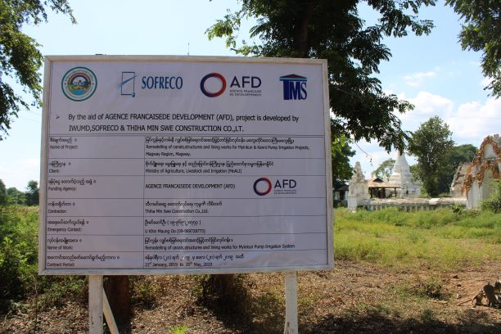
Photos of Site Visit of H.E the Ambassador and AFD Country Director – 31 Oct 2019
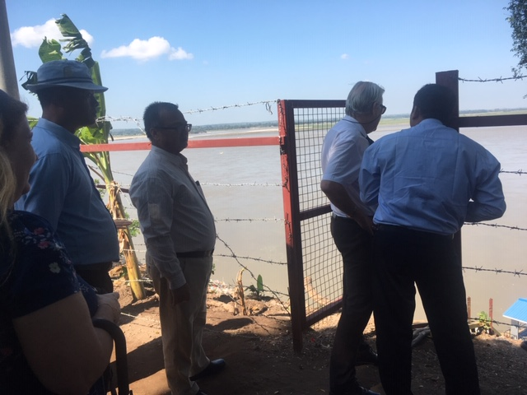 | 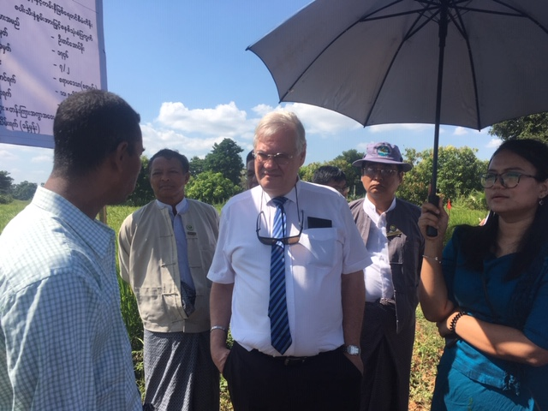
H.E.s and DDG at PS-1 in Myinkun PIP | H.E. interacting with Paddy Demonstration Farmer, U Win Maw Htay using SRI
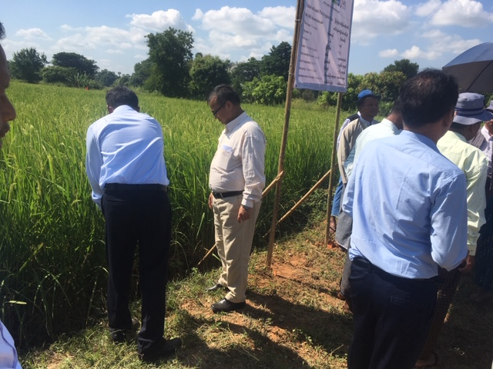 | 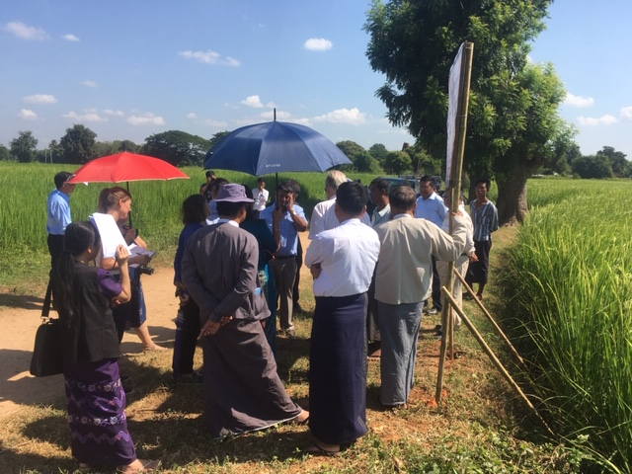
H.E. Minister for Agriculture and Irrigation observing the demonstration field of paddy | Information Sharing of System of Rice Intensification ( SRI ) of Demo Farm
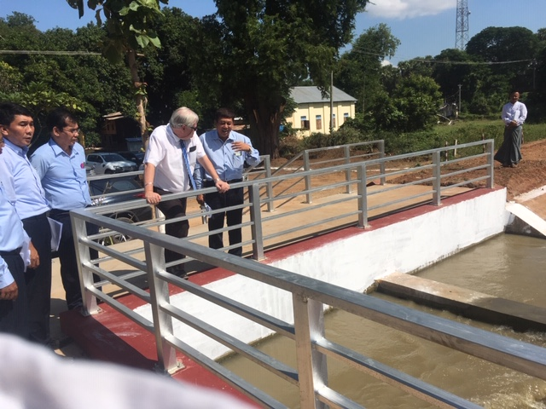 | 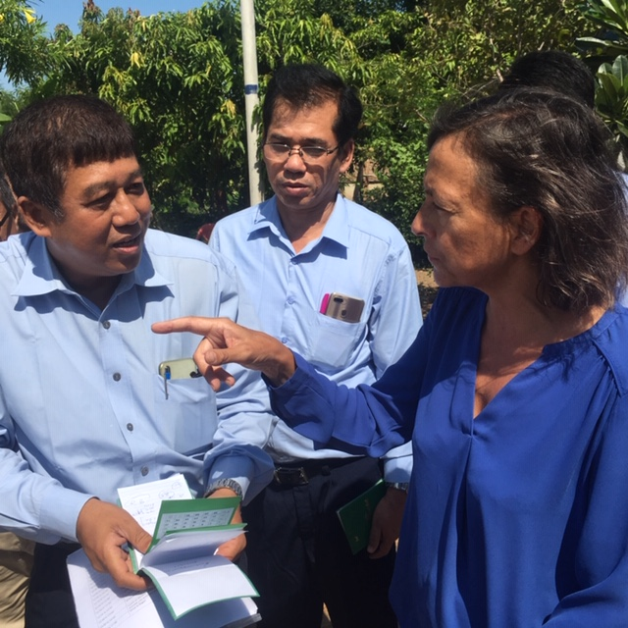
H.E and DDG at Stilling Basin & Main Canal of PS-2 Myinkun PIP | AFD Country Director with DDG – IWUMD in Myinkun PIP
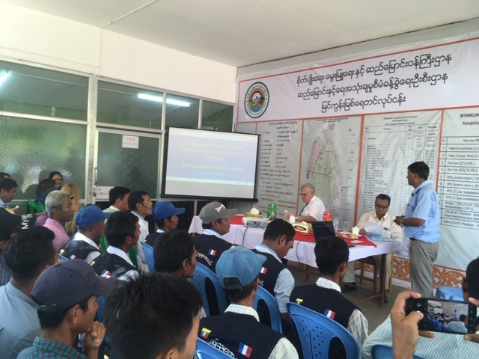 | 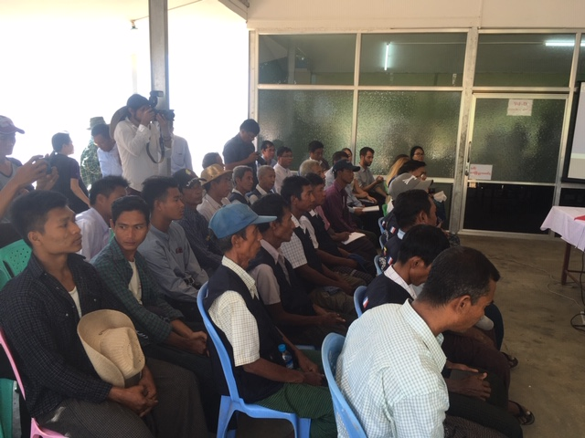
Interaction with the Water Users’ Association Management Committee in Myinkun PIP | WUA and farmers attending the visit program of H.E. the French Ambassador
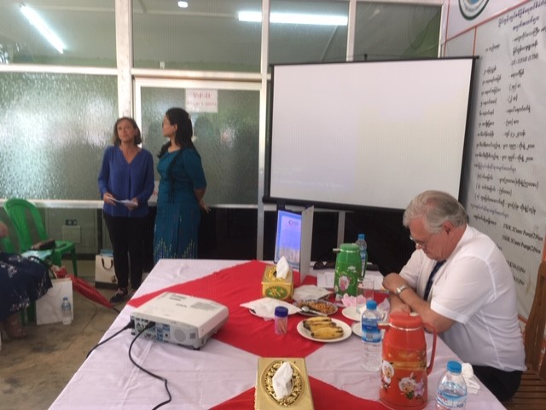 | 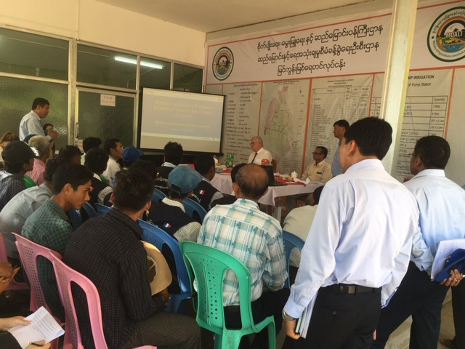
AFD Country Director delivering the closing remarks on the meeting with the farmers | DDG of IWUMD delivering welcome speech and presenting the progress and achievements of the Project
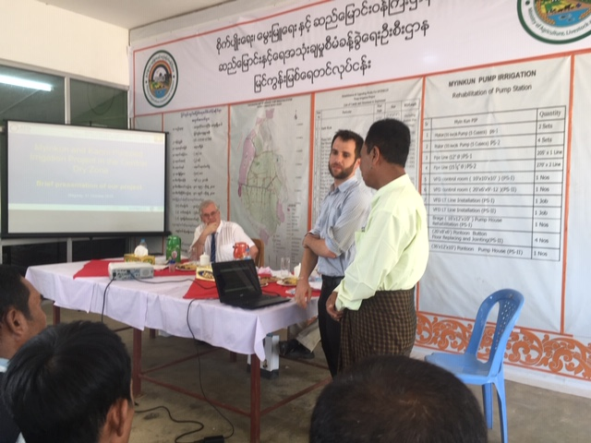 | 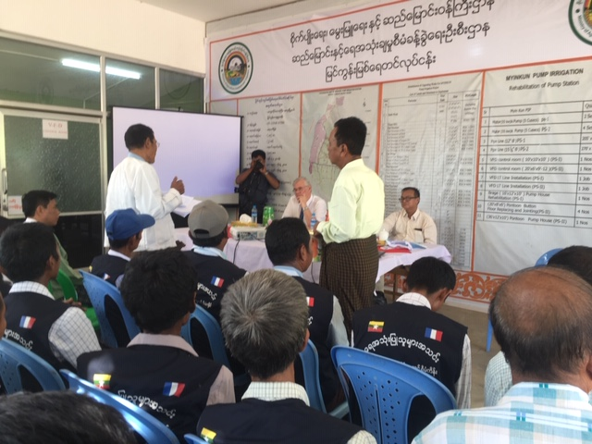
SOFRECO Representative for South East Asia presenting the progress report | Chairman of Water Users’ Association of Myinkun PIP expressing sincere gratitude to the H.E and AFD for the support to the project
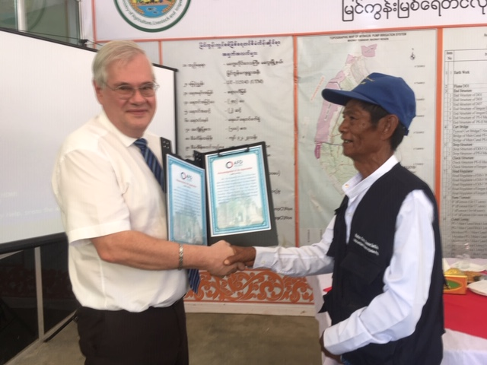 | 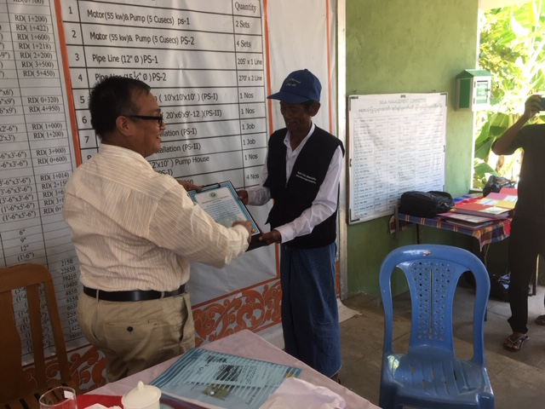
WUA member presenting Letter of Appreciation to H.E. the Ambassador | WUA member presenting Letter of Appreciation to H.E. the Minister for Agriculture and Irrigation, Magway Region
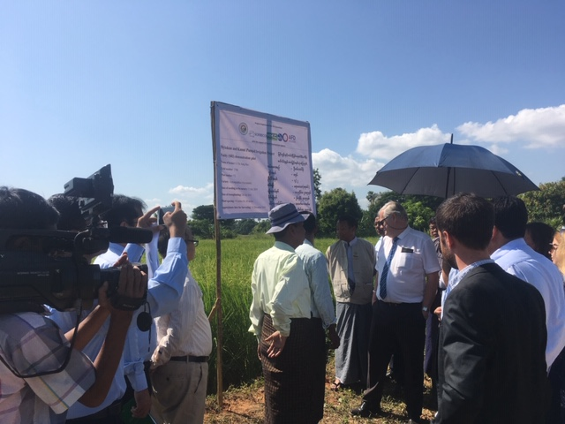 | 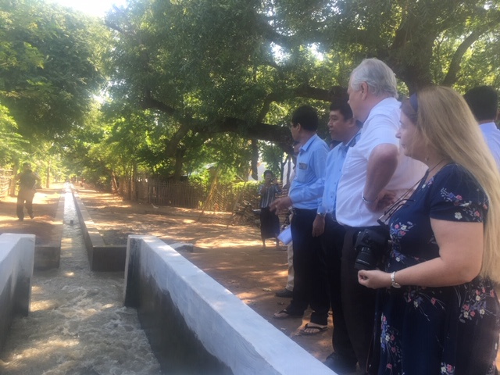
Observation of Demonstration of Paddy Cultivation using SRI | Pump Station -1 Site Visit
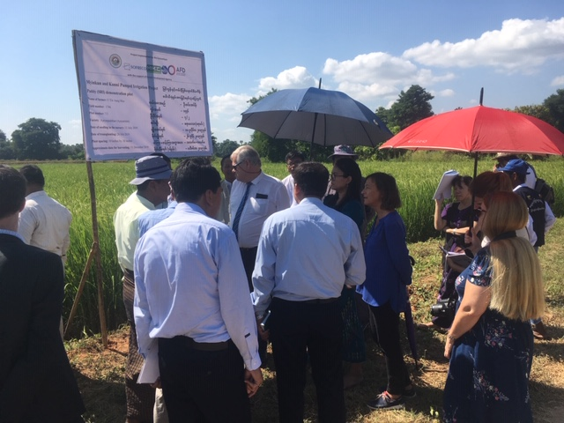 | 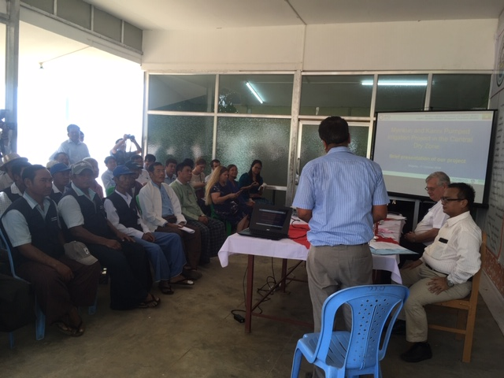
Ar Demo Farm on Paddy | Presentation of Progress by PTO TL
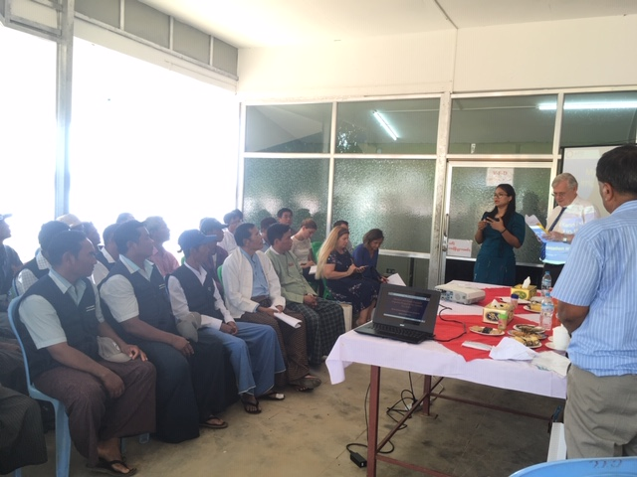 | 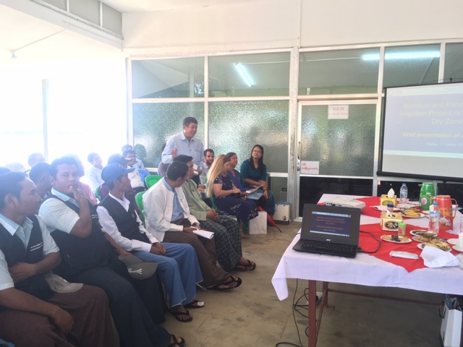
H.E the Ambassador addressing the audience | DDG IWUMD delivering welcome note
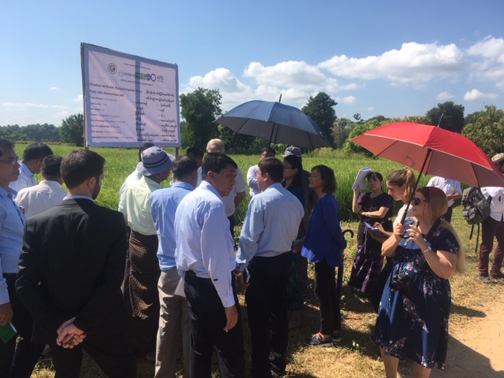 | 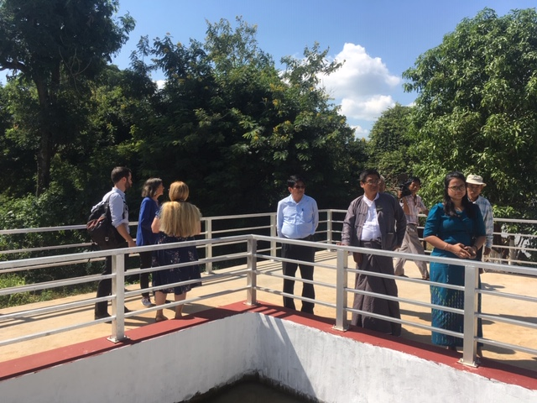
At demo farm on paddy | At Pump Station 2

